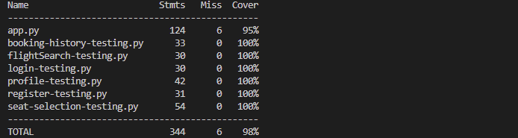

**Missing lines and explanations:**

**App.py:**

**Line 115: return render_template('register.html')**

This line displays the registration page if fields are left blank or passwords don’t match. We were able to test this interactively, so skipping it in automated tests is fine.

**Line 134: return render_template('login.html')**

This line appears when login fails due to incorrect credentials. Since we tested this interactively, we’re confident it works as expected even without automated coverage here.

**Line 139: return redirect(url_for('login'))**

This redirect enforces login before accessing certain pages. We tested this by navigating pages interactively, so missing it in automated tests is acceptable.

**Line 149: return jsonify({"error": "User not logged in"}), 401**

This error response occurs for API routes if the user isn’t logged in. We tested this functionality interactively, ensuring it operates as expected.

**Line 161: return jsonify({"success": False, "error": "User not logged in"}), 401**

Like Line 149, this handles unauthorized API access. Since this was tested interactively, covering it in automated tests isn’t critical.